**Salt and Pepper**

For the API application I made a .js file and I created a json file to create the bond.For the server it was used the 8080 port and when it is starting it writes in console that it has just started.There are two function implemented:get for all characters and get for characters with a specific id.For the first function it was created a connection with the database that is on port 3306 and the database name is “application” with table “characters”.Then a query syntax is made and if an error existed then the response should end.If not the data is serialize with json format and gets response.For the second function a variable called number is initialize with the parameter that is in url that corresponds with id.After that is much the same but when the query is parsed as parameter is given the number to get from database all characters with a specific id.

First Function:

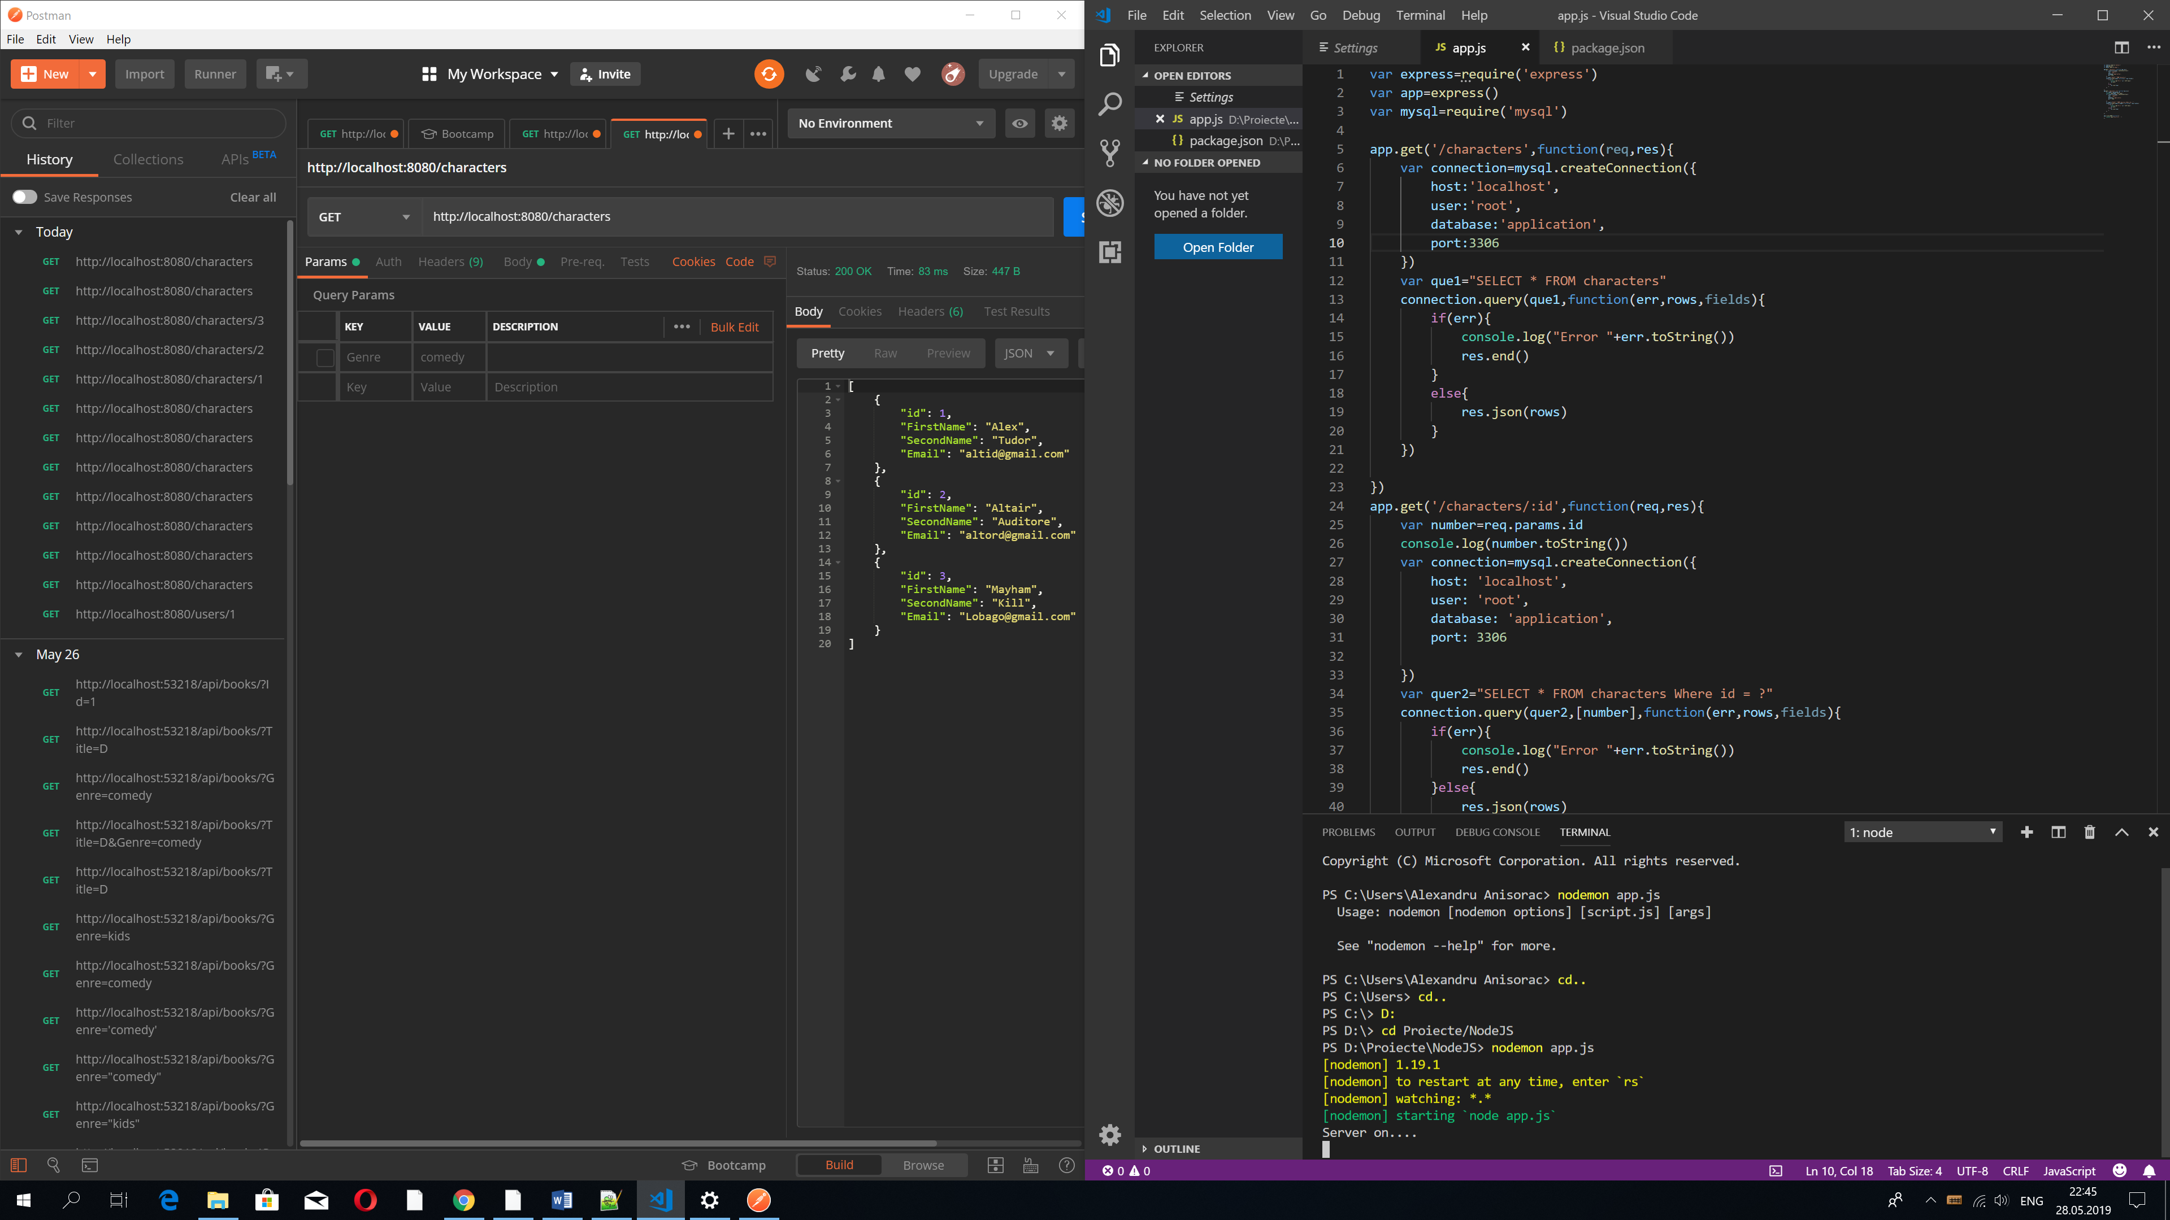

Second Function

